1. **Bisection method**

**Algorithm:**

**START**

**Step 1:** Define the polynomial function f(x) = a3*x^3 + a2*x^2 + a1*x + a0

**Step 2:** Input the following:

a. Coefficients of the polynomial (a3, a2, a1, a0)

b. Initial lower bound (xl) and upper bound (xu)

c. Desired precision (E)

**Step 3:** Calculate f(xl) and f(xu)

**Step 4:** Repeat until root is found or desired precision is reached:

a. Calculate midpoint: xm = (xl + xu) / 2

b. If f(xl) * f(xm) <= 0, set xu = xm; otherwise, set xl = xm

c. If |xu - xl| / |xu| < E, exit loop

**Step 5:** Repeat Step 4 until a root is found or the desired precision is reached.

**Step 6:** Output the root (xm)

**END**

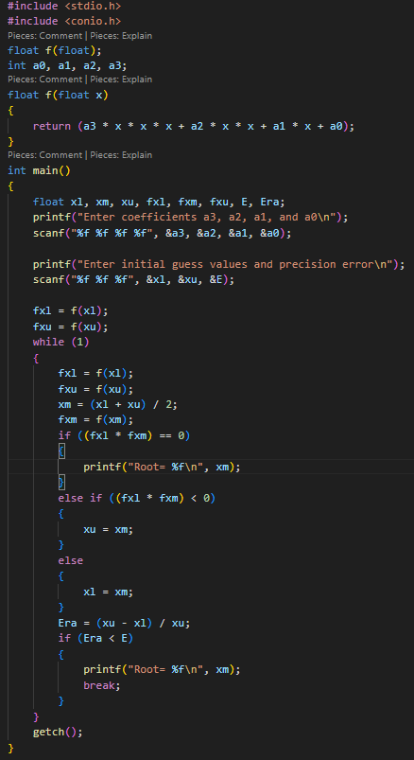**Code:**

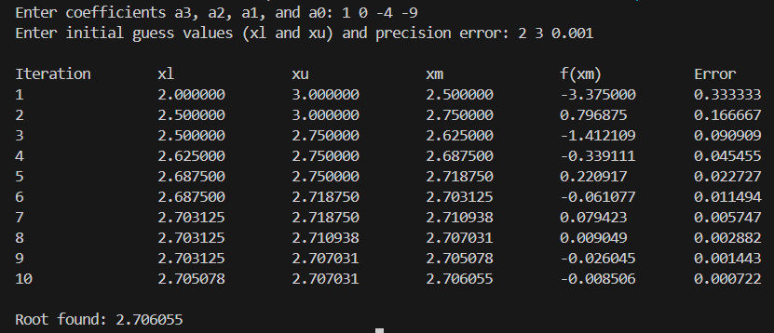**Output:**

1. **Newton-Raphson method**

**Algorithm:**

**START**

**Step 1:** Define the polynomial function F(x) = a3*x^3 + a2*x^2 + a1*x + a0

**Step 2:** Define the derivative function FD(x) = 3*a3*x^2 + 2*a2*x + a1

**Step 3:** Input: a. Coefficients of the polynomial (a3, a2, a1, a0) b. Initial guess (x0) c. Desired precision (E)

**Step 4:** Repeat until convergence:

a. Calculate F(x0) and FD(x0)

b. Compute next approximation: x1 = x0 - F(x0) / FD(x0)

c. Calculate relative error: Er = |x1 - x0| / |x1|

d. If |Er| < E, exit loop

e. Set x0 = x1 and continue to next iteration

**Step 5:** Output the root (x1)

**END**

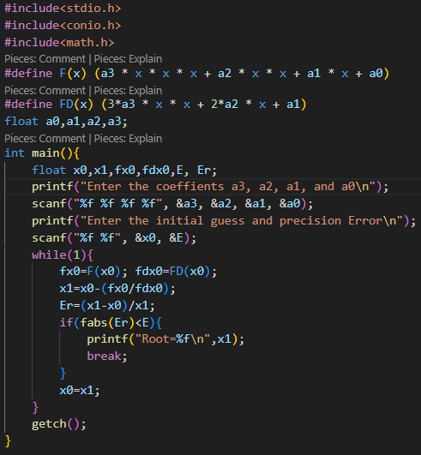**Code:**

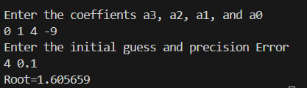**Output:**

1. **Fixed – Point method**

**Algorithm:**

**START**

**Step 1.** Define the function G(x) = (a3*x^3 + a2*x^2 + a0) / (-a1) This is derived from rearranging f(x) = a3*x^3 + a2*x^2 + a1*x + a0 = 0

**Step 2:** Input: a. Coefficients of the polynomial (a3, a2, a1, a0) b. Initial guess (x0) c. Desired precision (E)

**Step 3:** Repeat until convergence:

a. Compute next approximation: x1 = G(x0)

b. Calculate relative error: Er = |x1 - x0| / |x1|

c. If |Er| < E, exit loop

d. Set x0 = x1 and continue to next iteration

**Step 4:** Output the root (x1)

**END**

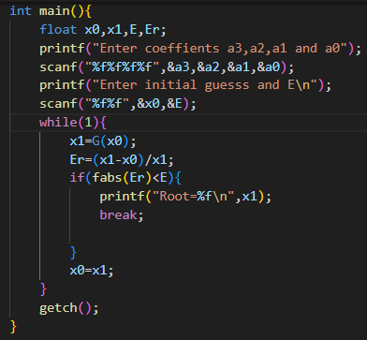**Code:**

**Output:**

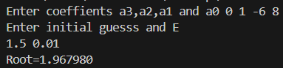

1. **Secant method**

**Algorithm:**

**START**

**Step 1:** Define the function F(x) = a3*x^3 + a2*x^2 + a1*x + a0

**Step 2:** Input: a. Coefficients of the polynomial (a3, a2, a1, a0) b. Two initial guesses (x0 and x1) c. Desired precision (E)

**Step 3:** Repeat until convergence:

a. Calculate F(x0) and F(x1)

b. Compute next approximation: x2 = x1 - F(x1) * (x1 - x0) / (F(x1) - F(x0)) c. Calculate relative error: Er = |x2 - x1| / |x2|

d. If |Er| < E, exit loop

e. Set x0 = x1 and x1 = x2

f. Continue to next iteration

**Step 4:** Output the root (x2)

**END**

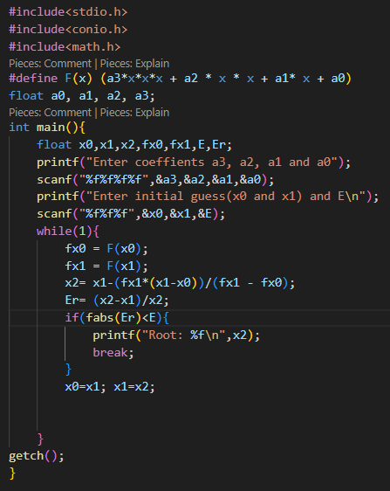**Code:**

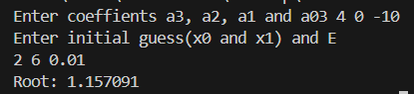**Output:**